**SELECTwithvariousclause–GROUPBY,HAVING,ORDERBY**

##### Questions:

GROUPBY- HAVING

1. Howmanystudentsareregisteredforeachcourse?Displaythecoursedescriptionandthenumberof studentsregisteredin eachcourse.
2. Howmanycoursesdideachstudent registerfor?UseAssessmenttable.

ORDER BY

1. RetrieveName,Gender,MobileNoofallthestudents inascendingorderofRegNo.
2. Listthefacultymembersintheorderofolderfacultyfirst.

##### OUTPUTS:

1)



2)



3)

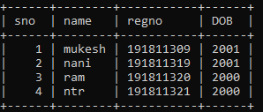

4)

